The Godly Play Christmas Eve Liturgy

This has been adapted by Peter Privett, to use at home.
But you could use it in other places too – outside, in a playground, in a church yard, in an empty car park. Look at the end for things you might need to help you.

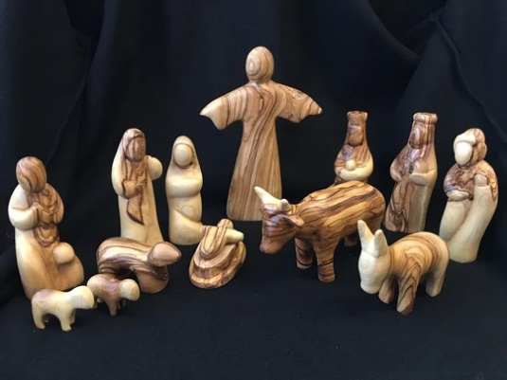
Before you begin you need to get ready.

You will need to find places in your home to keep the different figures of the Holy Family. You can use the whole space inside and outside. Be inventive. You need to create a sense of a journey.

You will need five different spaces to keep the following:
1 The cow and the sheep
2. Mary Joseph and the donkey
3. The Christ Child
4 The shepherds and an angel if you have one.
5 The Wise Ones, the Magi, and a star on a stick that can be carried.

You will also need to find a place where the figures can be assembled, your Bethlehem. You will know where this is to be. It could be inside or outside. You choose.

The words in Bold can be read by different people.

As you journey around your home you can also sing carols. You choose when and which ones.

You will need to make some stars beforehand, some for each person. These are placed near to your Bethlehem. Or you could buy a packet of stars or use some from the Christmas decorations.

Here is what to do and say
Start furthest away from the place you have decided to be Bethlehem.
When all are assembled someone reads the following.

This night is like no other night.
It is a time to dream and sing our way to Bethlehem.
The little town that we seek is in the hill country some ten miles south of Jerusalem.
For thousands of years the houses have huddled there on the hilltop
like a family breaking bread.
Bethlehem means ‘house of bread’.

All go the place where the sheep and cow are kept. They are then brought to your Bethlehem and placed there. Someone then says:

All is still and quiet.

Everybody now goes to the place where you have kept Mary, Joseph and the donkey. These are held as someone says:

As night gathers, the last two travellers come slowly up the road with their donkey.
Look, there is a young woman about to be a mother. She is walking with her husband.
They are Joseph and Mary from Nazareth.
They have walked for 6 days to come to this place where David the King was born
so long ago.
They have come, like so many others, because the Roman emperor wants to count each one, so that he can take their money in tax.

Bring the figures to your Bethlehem and hold them.

But it is late, and Mary is weary. Where will they sleep? There is no room in the inn.
They decide to sleep with the animals.

Place the figures with the sheep and the cow.

Go to the place where you have kept the baby. Somebody holds him,

Stars brighten slowly in the sky. All creation holds its breath.

Bring the baby to Bethlehem. Place him with the others.

Suddenly from the stable comes the cry of a newborn child. Mary gently wraps the baby in a blanket and lays him in the feed box filled with straw.

Have a moment of silence

Go the place where the shepherds (and if you have an angel) are kept. Someone holds them.
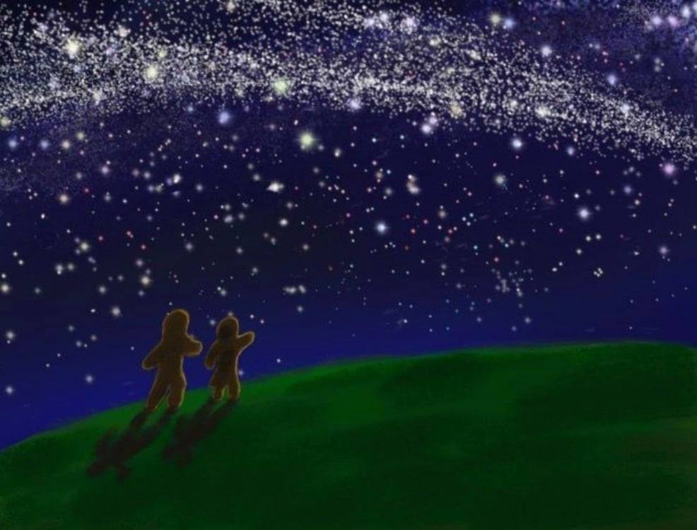
In the hills outside Bethlehem, shepherds watch their shadowy sheep.
All at once the dark is lost in light, and in the midst of the light is something even brighter, the faces of angels.
The fearful shepherds then hear singing in the sky, and a voice says, ‘Do not be afraid. Listen, I bring you news of great joy, a joy to be shared by all people. Today in the City of David a saviour is born. He is Christ the Lord.’
Then more angels appear, a whole heavenly host of them, praising God and singing:
‘Glory to God in the highest, and on earth peace to all people everywhere.’

The shepherds are brought to your Bethlehem and placed with the other figures.

The shepherds run with joy across the fields to the barn behind the inn. There they find the Holy Family and creep forward, overwhelmed with mystery, to find Nativity itself in the centre of all that love.

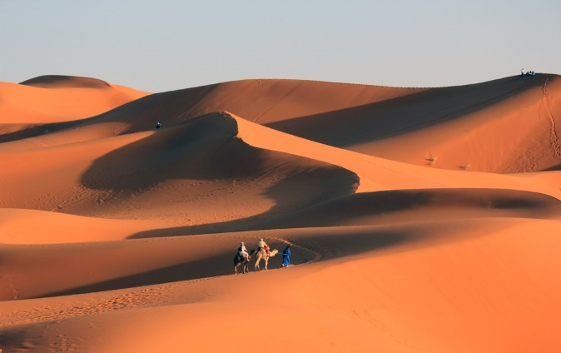
Go the place where the Kings, the Magi, are kept. These are held, also the star is held high.

Three camels plod up the road to Bethlehem.
They have come from the East, far beyond the Arabian desert, perhaps as far as the Caspian Sea.
The camels carry the kings, the wise ones, the Magi. They are following the wild star, the destiny they had never seen before.
They are following it wherever it goes, to find the King Its shining shows them.

The star leads everyone to your Bethlehem. The figures are placed with the others. Find somewhere for the star.

The Magi’s journey ends in a new kind of King. Their restlessness rests at last. They fall on their knees and give him bright gold, sweet smelling frankincense, and bitter myrrh, brought so far with so much love.

Enjoy the scene for a while

Each person then takes some stars and holds them.

So now we come, following the star to find God-with-us.
We come as people have come all through the ages,
to bring our gifts to this Child, God’s gift to us.

Everyone offers their stars.

Sing, dance, feast, enjoy one another’s company and keep safe!

Words in bold are from The Complete Guide to Godly Play Volume 3, Jerome Berryman, (2017) Church Publishing, New York.

Ideas for adapting this to use outside
- Make a place to be Bethlehem. You can use anything for this. Even a cardboard box would do.
- Families could stand in socially distanced groups.
- Different groups could each have a person or a creature which they can bring to your Bethlehem when it is their turn.
- They can take it in turns to come to Bethlehem so that they don’t come too close to each other. You may have to think about how you organise that a bit.
- You could ask people to bring their own stars, or you could give them some stars in a little envelope when they arrive. Outside they need to be paper or something else biodegradable, in case they blow about. Another idea would be to cut up bits of doily. Look on the internet for ways to make paper stars or to by them.

Hark! the herald angels sing, ‘Glory to the new-born King!’
Peace on earth and mercy mild,
God and sinners reconciled!
Joyful, all ye nations, rise, join the triumph of the skies,
With the angelic host proclaim:
‘Christ is born in Bethlehem.’
Hark! the herald angels sing,
‘Glory to the new-born King!’

Lord Jesus Christ,
your birth at Bethlehem
draws us to kneel in wonder at heaven touching earth:
accept our heartfelt praise as we worship you,
our Saviour and our eternal God.
Amen.

