Laughter!
‘The laughter of Godly Play flows out of God’s playful presence.’ (Jerome Berryman)
‘God has brought laughter for me; everyone who hears will laugh with me.’ (Genesis 21.6)

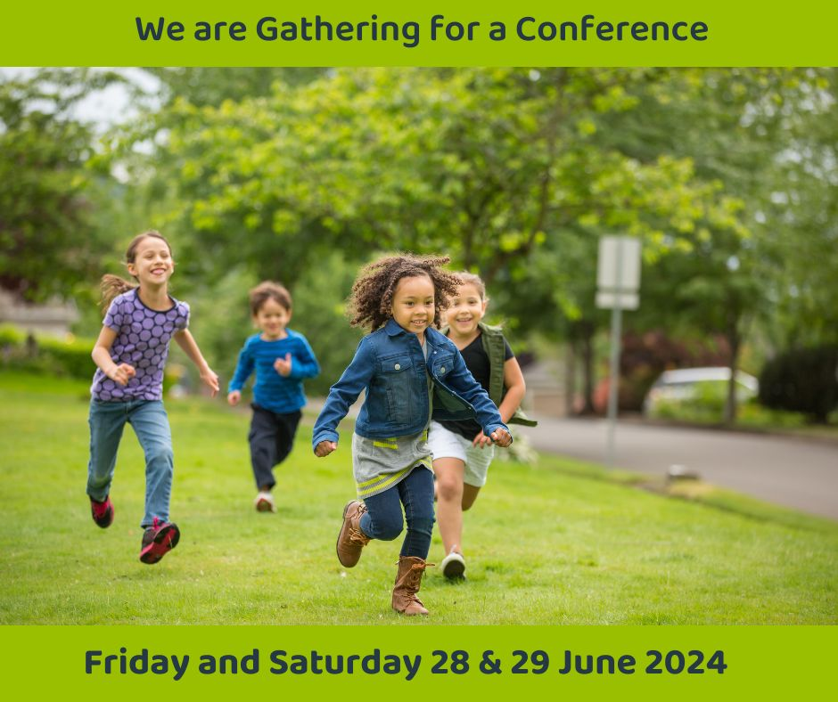
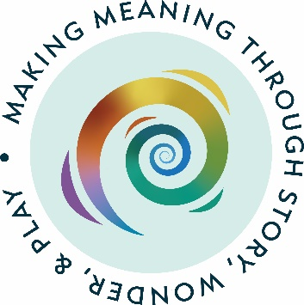
St Mary De Crypt Church, Gloucester
Enrichments and evening social event: Friday 28 June
Full Conference: Saturday 29 June

Friday 28 June 2024 Enrichment Days
Trauma-informed Godly Play
What do you think of when you hear the word ‘trauma’? Do you think of a wound - physical or emotional; or do you think of a painful event? How might trauma manifest in a child or adult’s behaviour? It is something that people are talking about more and more as we understand the impact of trauma on adults and children; in fact, the whole of society.
What Godly Play can teach us about being trauma-informed? This enrichment day will include the experience of a full Godly Play session before we consider how the underlying principles support a trauma-informed approach. It is relevant to Godly Players from all settings and will seek to clarify what it means to be trauma-informed. Time will be given to transfer our learning to specific contexts, questions and appropriate resources.

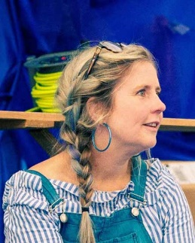
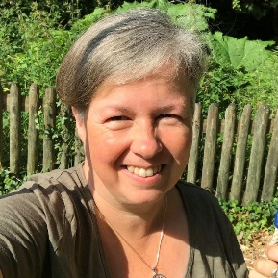
Susie Steel
Susie is a Godly Play UK trainer based in Hull. After teaching for more than 25 years, Susie discovered the research that had been done into the impact of trauma on children. She then became something of an activist, working to raise awareness in Hull through film screening and a conference. She now trains adults in the impact of trauma with ACEs UK and also works as a Family Practitioner in a Women’s Refuge. One day a week she works as a Mission Enabler for a Methodist Church where she runs a baby group and hopes to start parenting groups and a Godly Play afterschool group.
Siân Hancock
Based in Bristol, Siân has worked with children, young people and their families in a range of community settings over the years including church, pre-school and primary school. As well as being an educator, Siân is an advocate for children and young people affected by domestic abuse and crime, supporting them with trauma informed approaches and accompanying them through the criminal justice system when necessary. She is a Godly Play UK Trainer and Associate Tutor at Bristol Baptist College. Siân has a doctorate in Practical Theology where her research focussed on the faith development of girls aged 7-14 years.
Making Materials Peter Privett and Heather Moger
Come and spend a day making Godly Play materials. Peter Privett is Godly Play UK’s most experienced trainer. He is also an artist and teacher, extremely experienced in helping people to make what they need to develop their Godly Play resources. He will be helped by Heather Moger who set up a Godly Play classroom in Stornoway in the Hebrides.
An Introduction to Godly Play Richard Knott
Come and experience a day of Godly Play discovering the breadth of what it has to offer – an ideal opportunity to introduce a friend or colleague to Godly Play. Richard is a Godly Play trainer and the Children and Youth Development Officer for the URC in the East Midlands.
Friday 28 June 2024 Evening Gathering
There will be a chance to meet up with other Godly Play people socially over a light meal. This is an ideal opportunity to develop networks and get to know others.
Saturday 29 June Conference
Our main speaker on Saturday is Ian MacDonald
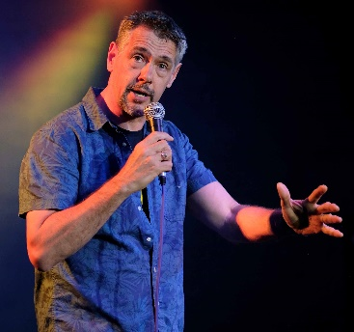
Ian Macdonald is passionate about human flourishing, facilitating ways for people to live into and from the deeper self – being more able to be with themselves, with others, and with God. He describes himself as a ‘Laughter Enabler, Storyteller and Theologian!’ Ian is passionate about laughter (to this end he teaches a happiness course, is a laughter yoga instructor and a stand-up comedian) and about storytelling. Trained by the Hearth Community, he teaches storytelling, and is a member of the Society for Storytelling. He believes that western culture has lost so much of what it means to live, tell and engage with story. Ian is Tutor in Mission at Sarum College. He has one wife, three quirky, wonderful grown-up children, and one dog; these have been some of his greatest teachers.
Afternoon Workshops There will be an opportunity to take part in two one-hour long workshops.
Godly Play in Schools Daniel Norris, Head of St Jérôme Church of England Primary School, Harrow
St Jérôme’s School opened in 2016 at the centre of the north-west London suburb of Harrow-on-the-Hill. The area is extremely diverse and 39 different family languages are represented among pupils. From the first, Godly Play influenced the ethos and development of the school, with a visible threshold at the entrance to every classroom and a deliberately community approach to the eating area, where all students eat lunch alongside members of staff and many children also have breakfast and an evening meal. A dedicated Godly Play room was created in the school from its inception and every child experiences a full Godly Play session fortnightly from a dedicated teacher. Daniel Norris has been the Headteacher of St Jérôme’s since its inception. He is a priest in the Church of England.
Trauma-informed Godly Play Susie Steele and Siân Hancock, Godly Play trainers
What Godly Play can teach us about being trauma-informed? This workshop will consider how the underlying principles of Godly Play support a trauma-informed approach to work with children and young people.
Laughter Yoga Ian MacDonald
Our morning speaker invites you to try out laughter yoga with him.
Godly Play story
A chance to experience a story within the context of a one-hour Godly Play session.
I’ve got a question: A Godly Play surgery Mary Hawes
Godly Play is an art, not a science and we never stop learning. Come and join a café-style discussion over the things you wonder about. Mary is a Godly Play Trustee and was formerly the CofE’s national Growing for Growth Officer.
Travelling Godly Play Alison Summerskill
We are often invited to take Godly Play into neighbouring venues - schools, churches, training groups. This session will explore what you really need and how to get it there.
The Godly Play Serendipity Stall will be open for browsing and buying.
Why Gloucester?
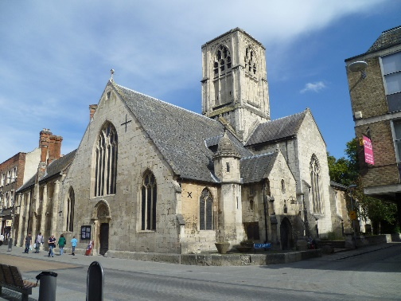
Our last two conferences have been in Sheffield and it seemed fair to move to a different part of the country to balance out access possibilities for people!
St Mary De Crypt is a medieval church in the centre of Gloucester and is associated with Robert Raikes, who publicised the Sunday School movement through the pages of his newspaper and thus contributed significantly to its phenomenal growth at the end of the eighteenth century. It has therefore been associated with valuing ministry with children over two centuries! The church has had a chequered past — it was an armament store during the Civil War and sustained cannon ball fire; its crypt was at one time used as an inn; George Whitfield preached his first sermon there and so inflamed the passions of the congregation that complaints were made to the bishop. Today it has been sensitively restored and is a warm and hospitable space for various groups throughout the city, with a strong focus on the arts and social justice. We shall also have use of the Friends’ Meeting House which is very close by for some of the afternoon workshops.
The church is 15 minutes’ walk from Gloucester railway station (around 2 hours from London, 1 hour from Birmingham) and close to the redeveloped Gloucester Docks area where there are car parks and hotels.
Saturday Conference Tickets
£50 (Early Bird Discount £10 up to the end of March, making tickets £40)
This includes lunch and refreshments.
Enrichment Days on Friday
Trauma-informed Godly Play £30 Introduction to Godly Play £30
Making Materials Day £12, plus the cost of materials
Please bring a packed lunch for enrichment days.
Book online at https://www.godlyplay.uk/events/godly-play-uk-conference-2024/

