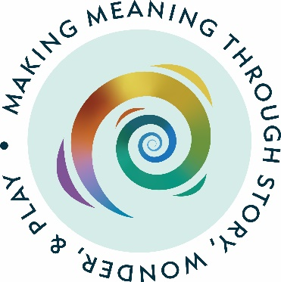

Application form for a bursary to attend a
Godly Play UK three-day training course or Train the Trainers course

Godly Play UK makes 10% of its annual gain available to subsidise the costs of attending one of its training courses, subject to applicants fulfilling the requirements for a bursary outlined below and adequate funds being available. Bursaries are awarded to applicants based on their personal circumstances and can help those who may face financial barriers to attending Godly Play UK training events. In all matters concerning potential financial assistance, the decision of the trustees will be final.

In addition, the aims of the GPUK Associates include supporting the spread of GPUK throughout England and Wales, and funds may be made available to support a 3-day course in an area of deprivation or to support an individual to attend a Train the Trainers course.

If you would like to apply for a bursary, please complete the application form for a bursary from Godly Play UK and email it to the Chair, detailing how you fulfil the below criteria.

Criteria for receiving a bursary to attend a three-day accredited course:
- Applicants must be from churches and/or areas where resources are scarce (e.g. Urban Priority Areas, Rural Communities).
- Wherever it is possible, joint funding with other bodies to cover accommodation and travel costs is preferable.
- Ideally two applicants are preferable. This is to ensure mutual support as Godly Play is developed and established in the applicants setting after the course.
- Applicants from areas and/or denominations where Godly Play is not yet established are welcome.
- Applicants must be able to demonstrate a thought-out strategy to disseminate Godly Play within their setting.
- Applicants from churches will need a positive and supportive reference from their church leader to show they have the support of their denomination.
- Christian church ministers who apply for a bursary will need to be part of a church that belongs to Christians Together in Britain and Ireland (CTBI). CTBI is the national ecumenical instrument supporting and encouraging churches from a wide range of traditions to work together in unity.
- Applicants should provide details of at least one – and preferably two – further referees who can positively support the application.
- Successful applicants will be expected to submit a progress report to the Chair of the trustees 6 months after the end of the course.

Criteria for receiving a bursary to attend a Train the Trainer course:
- Applicants are strongly advised to seek an informal discussion with one of the GPUK Lead Trainers before making an application.
- Applicants must be from churches and/or areas where resources are scarce (e.g. Urban Priority Areas, Rural Communities).
- Wherever it is possible, joint funding with other bodies to cover accommodation and travel costs is preferable.
- Candidates must show prior knowledge, experience and a commitment to Godly Play
- Applications form areas and/or denominations where Godly Play is not yet established are welcome.
- Applicants must be able to demonstrate a thought-out strategy to disseminate Godly Play within a wide area.
- It will be helpful if Applications hold a teaching or training qualification but this is not essential.
- Applicants will need a positive and supportive reference from their Church Leader to show they have the support of their denomination.
- Applicants should provide details of at least two – and preferably three – further referees who can positively support the application.
- Applicants will undergo an in-depth assessment and interview process before being accepted.
- Applicants will need access to GPUK resources.
- Applicants who complete the course and are accepted as a GPUK trainer must sign the Trainer Agreement.
- Successful candidates must agree to working with their allocated mentor and attending on-line Trainer meetings where appropriate.
- Successful candidates will be invited to Trustee/Trainer meetings which take place once or twice a year.
- Successful candidates must commit to working alongside an experienced trainer to deliver a 3-day course within 1 year before going on to work independently as a Trainer
- Successful applicants will be expected to submit a progress report to the Chair of the Trustees 1 year after the end of the course.

Please note: Details (but not names) of those awarded bursaries will be reported in the Charity's Annual Report.

Applicant’s Full Name

Address

Email address

Phone contact number

Name of your organisation (church, etc.)

What is the venue of the course that you would like to attend?

What are the dates of this course?

Please outline as fully as possible your reasons for applying for a bursary and how you fulfil the bursary criteria

(Please attach a separate sheet if necessary)

Are you applying for a discount on more than one place? Yes/No

What will be your strategy for using and / or disseminating Godly Play in your area in the future?

(Please attach a separate sheet if necessary)

Referees

Church Leader reference contact details

Name

Role

Address

Email address

First reference contact details

Name

Relationship to the applicant

Address

Email address

Second reference contact details

Name

Relationship to the applicant

Address

Email address

Third reference contact details (Train the Trainer only)

Name

Relationship to the applicant

Address

Email address

Please submit this form to Gill Ambrose, Chair of Trustees, Godly Play UK, gill.ambrose@godlyplay.uk

